Consider this example, suggestive of manipulation of a broad array of US stocks in 2011 Aug 9 from 2:45PM EDT to 4PM.
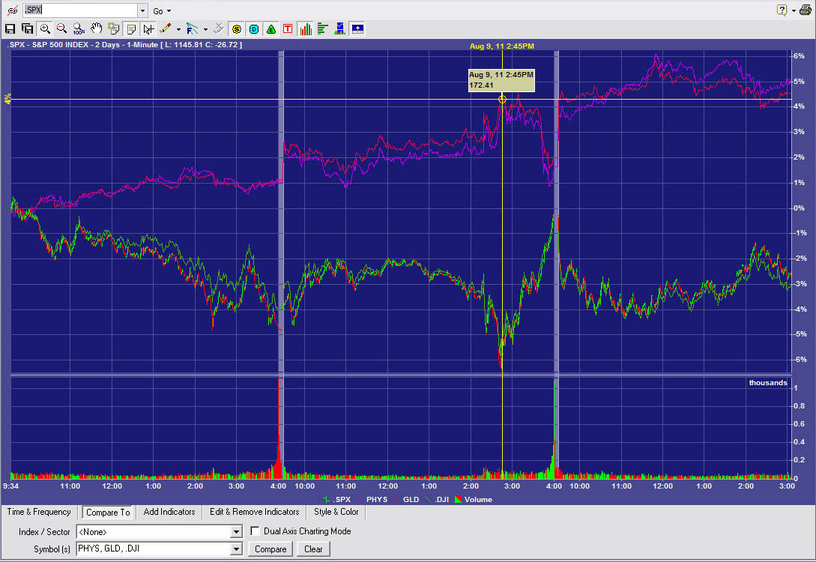
The time sequence is as follows. See Monday, Tuesday, Wednesday chart above. The chart shows % changes from Monday at 9:34AM.

Monday, Tuesday, and Wednesday PHYS and GLD, both representing spot gold tracked together. Likewise the DOW Jones Industrial Average and the S&P500 index representing blue chip stocks closely tracked each other. This is typical of other time periods also.
From Monday at 9:34AM to Tuesday noon Gold was up a little over 2%. Over the same period blue chip stock averages were down about 2%.
At 2:15 Tuesday stocks are down about 3%. At that time (I can’t find absolute proof of the minute) the Federal Open Market committee made public its Press Release of the just-concluded FOMC meeting. The report was immediately taken by many to be bad news. See table below.
Posted 2011-08-09 14:37 (Only about a half-hour after the report was released! | This is a massive downgrade on the economy folks.... Denninger then interprets the paragraphs, one-by-one. “The economy is going to hell. In other words, we're back in recession. ZIRP for at least two more years. This is REAL dissent – three [dissenters], not one.”
Posted 2011-08-09 15:39 | Bernanke Calls Deflationary Depression.
Submitted by Tyler Durden on 08/09/2011 16:02 -0400 | Russ Certo: "The Fed Just Basically Announced Recession"

The chart shows that the markets were taking the press release as bad news. By 2:45 Stocks, are down another 3% just in that half hour – down 6% since Monday. During the same time period, gold is up about ½% -- up about 4% since Monday.The initial reaction was short-lived.
At 2:45PM Stocks and gold both do an about-face!!
Between 2:45 and 4:00PM gold drops about 2% and stocks go up almost 6%!!
A day later, respected Bloomberg analyst Jonathan Weil attributed the entire afternoon’s market behavior to the FOMC report:
“By pledging to keep its benchmark interest rate near zero through at least mid-2013, the Federal Reserve succeeded (for a couple of hours) in propping up U.S. stock markets after two days of gut-wrenching declines, especially in financial stocks.”
Thus his analysis of the Federal Reserve Press Report sees it as a positive market-mover. And he mentions no event at 2:45 that would explain the sudden reversal of investor sentiment re stocks and re gold. It’s as if he thinks investors were just confused from 2:15 to 2:45 PM.
Overnight and Wednesday this strange behavior 2:45 to 4 PM Tuesday was largely dissipated/overridden: a second unexplained investor sentiment reversal.
There have been several other similar S&P 500 reversals of sentiment from negative to positive extending from about 3PM or about 3:30PM to 4PM.

All % numbers below are from this time unless it’s stated otherwise.

